Add a Customer

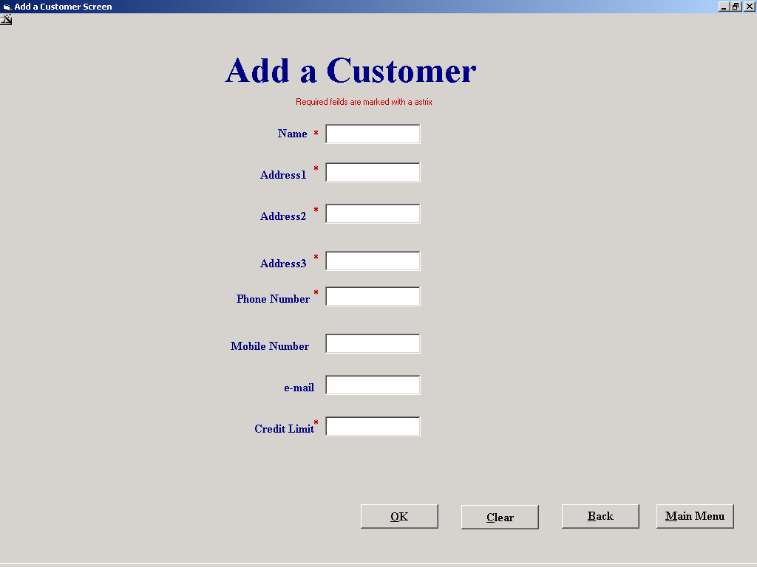

'Purpose This form allows the user to Display a add a new customer to the
' Customer table
'Student David Hamilton
'StudentID Com2023
'Last Modified 15/3/02

'Variables used
'intID Integer
'intResponse Integer

Option Explicit

'If the this form was opened from the Equipment Hire screen then a string
'will have been placed in the form tag else this form must have been opened
'from the Main Menu so return their
Private Sub cmdBack_Click()
If frmAddCustomer.Tag <> "" Then
frmRental.optNumber = False
frmRental.optName = True
frmRental.cboName.Visible = True
frmRental.cboNumber.Visible = False
frmRental.optNumber.Enabled = False
frmRental.optName.Enabled = False
frmRental.cboName.Enabled = False
frmRental.cboNumber.Visible = False
frmRental.cmdAddCust.Enabled = False
frmRental.lblNameNumber = "New Customers Name"
frmRental.cboName = txtName
frmRental.txtCustID = ""
frmRental.txtNameFound = ""
frmRental.txtAddress1 = ""
frmRental.txtAddress2 = ""
frmRental.txtAddress3 = ""
frmRental.txtPhoneNo = ""
frmRental.txtMobileNo = ""
frmRental.txtEmail = ""
frmRental.txtCreditLimit = ""
frmRental.txtStatus = ""
frmRental.txtBalance = ""
frmRental.datCustomer.Refresh
Else
frmCustomerFileProcessing.Show
End If

Unload Me
End Sub

'Empties text boxes
Private Sub cmdClear_Click()
txtName = ""
txtAddress1 = ""
txtAddress2 = ""
txtAddress3 = ""
txtPhoneNo = ""
txtMobileNo = ""
txtEmail = ""
txtCreditLimit = ""
txtName.SetFocus
cmdSave.Enabled = False
End Sub

Private Sub cmdMainMenu_Click()
If Len(txtCreditLimit) > 0 Then
intResponse = MsgBox("Do you wish to save before you Exit", vbYesNo, "Save Now")
If intResponse = vbYes Then
cmdSave_Click
Else
cmdClear_Click
End If
End If
frmMainMenu.Show
Unload Me
End Sub

'Create a new customers ID then save the contents the screen to a table then
'Clear out the text boxes
Private Sub cmdSave_Click()

Dim intID As Integer
Dim intResponse As Integer

If Not datCustomer.Recordset.BOF Then
datCustomer.Recordset.MoveLast
If intID >= datCustomer.Recordset("Cust_ID") Then
intID = intID + 1
Else
intID = datCustomer.Recordset("Cust_ID")
intID = intID + 1
End If
Else
intID = 1
End If

intResponse = MsgBox("Click OK to save inputted Data", vbOKCancel, "SAVE NOW")
If intResponse = 1 Then
datCustomer.Recordset.AddNew
datCustomer.Recordset("Cust_ID") = intID
datCustomer.Recordset("Name") = txtName
datCustomer.Recordset("Address 1") = txtAddress1
datCustomer.Recordset("Address 2") = txtAddress2
datCustomer.Recordset("Address 3") = txtAddress3
datCustomer.Recordset("Phone No") = txtPhoneNo
datCustomer.Recordset("Mobile No") = txtMobileNo
datCustomer.Recordset("E-Mail") = txtEmail
datCustomer.Recordset("Credit Limit") = txtCreditLimit
datCustomer.Recordset("Status") = "Normal"
datCustomer.Recordset("Balance owed") = 0
datCustomer.Recordset.Update

Else
cmdClear_Click
End If
cmdSave.Enabled = False

End Sub

Private Sub Form_Activate()
txtName.SetFocus
End Sub

Private Sub Form_Load()

datCustomer.DatabaseName = "G:\EqpthireProject\EHS.mdb"
datCustomer.RecordSource = "Customer"
datCustomer.Refresh
End Sub

'uses the validate function to ensure esential data is taken in

Private Sub txtAddress1_Validate(Cancel As Boolean)
Dim intResponse As Integer
If Len(txtAddress1) = 0 Then
Cancel = True
intResponse = MsgBox("You must enter data into this field", vbOKOnly, "Please fill out the form properaly")
If intResponse = 1 Then
txtAddress1.SetFocus
End If

End If

End Sub

Private Sub txtAddress2_Validate(Cancel As Boolean)
Dim intResponse As Integer
If Len(txtAddress2) = 0 Then
Cancel = True
intResponse = MsgBox("You must enter data into this field", vbOKOnly, "Please fill out the form properaly")
If intResponse = 1 Then
txtAddress2.SetFocus
End If
End If
End Sub

Private Sub txtCreditLimit_Validate(Cancel As Boolean)
Dim intResponse As Integer
If Len(txtCreditLimit) = 0 Then
Cancel = True
intResponse = MsgBox("You must enter data into this field", vbOKOnly, "Please fill out the form properaly")
If intResponse = 1 Then
txtCreditLimit.SetFocus
End If
ElseIf Not IsNumeric(txtCreditLimit) Then
Cancel = True
intResponse = MsgBox("You must enter a number in this box", vbOKOnly, "Numders only")
If intResponse = 1 Then
txtCreditLimit.SetFocus
End If
End If
cmdSave.Enabled = True
End Sub

Private Sub txtName_Validate(Cancel As Boolean)
Dim intResponse As Integer
If Len(txtName) = 0 Then
Cancel = True
intResponse = MsgBox("You must enter data into this field", vbOKOnly, "Please fill out the form properaly")
If intResponse = 1 Then
txtName.SetFocus
End If
End If
End Sub

Private Sub txtAddress3_Validate(Cancel As Boolean)
Dim intResponse As Integer
If Len(txtAddress3) = 0 Then
Cancel = True
intResponse = MsgBox("You must enter data into this field", vbOKOnly, "Please fill out the form properaly")
If intResponse = 1 Then
txtAddress1.SetFocus
End If
End If
End Sub
Private Sub txtPhoneNo_Change()
Dim intResponse As Integer
If Len(txtPhoneNo) = 0 Then
Cancel = True
intResponse = MsgBox("You must enter data into this field", vbOKOnly, "Please fill out the form properaly")
If intResponse = 1 Then
txtPhoneNo.SetFocus
End If
End If
End Sub

